Lab 3.2

Refer to Chapter 2: Getting Started with CSS

1. Read pages HTML 108 to HTML 132
2. Using the tss_styles.css file from Lab 3.1, and data files provided, complete Section 2.2
3. Display the completed tss_home.html file in a browser as directed on page HTML 132, Step 3.
4. Compare your display to Figure 2-20 on page HTML 132. Correct any errors.
5. Add a screenshot of the tss_home,html file displayed in the browser.
6. Review the Section 2.2 Quick Check with a classmate.

Screenshot of tss_home.html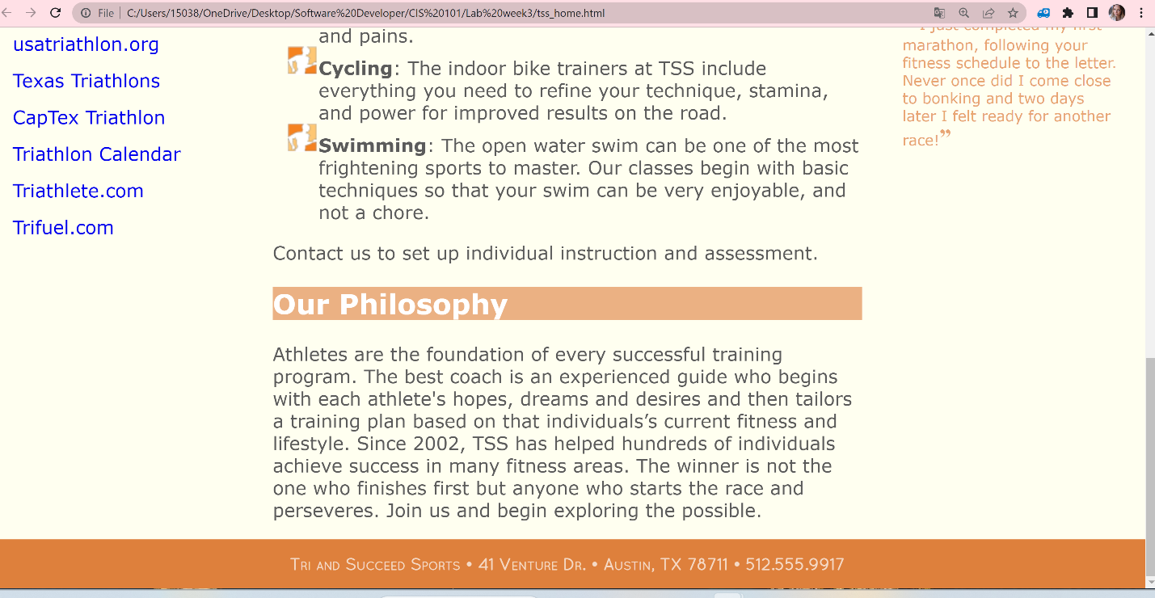

Using a numbered list, add 10 things you have learned by completing Section 2.2 of Tutorial 2.

1. Types of pattern
2. Contextual selector, specifies the context under which a particular page element is used.
3. Sibling selectors select elements based on the elements that are adjacent to them in the document hierarchy.
4. The general rule in CSS is that the more specific selector takes precedence over the more general selector, but the application of this rule is not always clear
5. Text characters are based on fonts that define the style and appearance of each character in the alphabet.
6. A general rule for printing is to use sans-serif fonts for headlines and serif fonts for body text.
7. Setting the Font Size
8. Context is very important with relative units.
9. Working with Font Styles
10. Text can be aligned horizontally or vertically within an element. To align the text horizontally, use the following text-align property